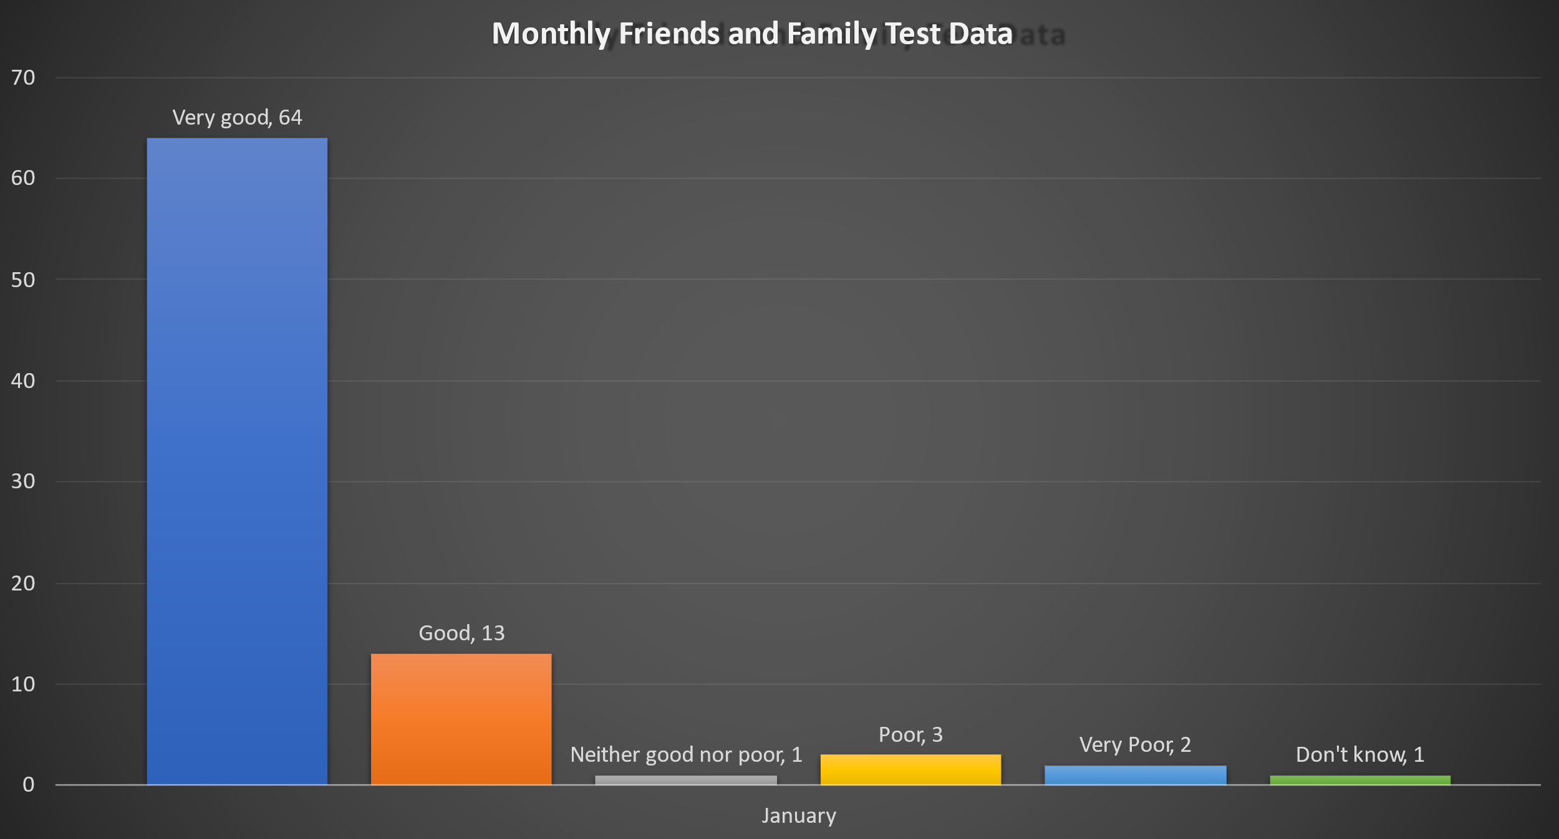

Very good = 64 Very poor = 2

Good = 13 Don’t know = 1

Neither good nor poor = 1

Poor = 3